- Configure RIP Concepts Theory

Q1. Set up a network topology with three routers in Cisco Packet Tracer, connect them using serial or Ethernet links, and assign IP addresses to all interfaces?

Answer
- I created a network topology using three routers (Router0, Router1 and Router2) in Cisco Packet Tracer.
- I connected all three routers using Ethernet cables in a triangle topology. I assigned IP addresses to each router interface using a /30 subnet mask for router-to-router connections and a /26 subnet mask for LAN connections.
- IP Addressing Table:
Connection | Network Address | CIDR
- Router0 ↔ Router1 | 199.168.1.0 | /30
- Router1 ↔ Router2 | 199.168.1.4 | /30
- Router2 ↔ Router0 | 199.168.1.8 | /30
- Router0 LAN | 199.168.1.64 | /26
- Router1 LAN | 199.168.1.128 | /26
- Router2 LAN | 199.168.1.192 | /26

After assigning IP addresses, I enabled all interfaces using the no shutdown command.
- Result: All three routers were successfully connected, and their interfaces were active.
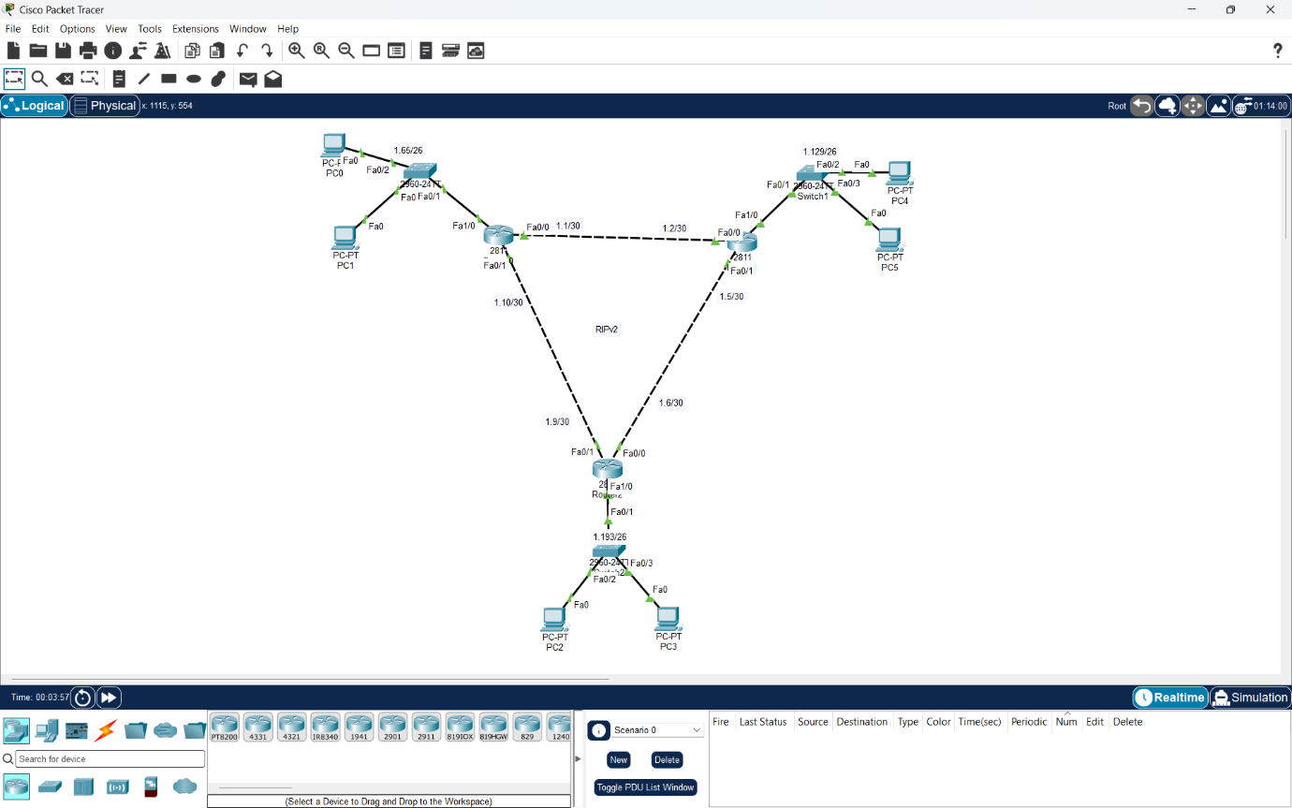

Q2. Enable RIP version 2 on all three routers in your topology, advertise all directly connected networks, and verify that each router learns routes to all subnets using the 'show ip route' command?

Answer
I configured RIP Version 2 on three routers (Router0, Router1 and Router2) in Cisco Packet Tracer.
- I used the following commands to enable RIP Version 2:
enable
configure terminal
router rip
version 2
network 199.168.1.0
end
- After configuring RIP, I used the following commands to verify routing:
- show ip route
- show ip protocols
- Observed Routing Table:
Router | RIP-Learned Networks | Hop Count
- Router0 | 199.168.1.4/30, 199.168.1.128/26, 199.168.1.192/26 | 1
- Router1 | 199.168.1.8/30, 199.168.1.64/26, 199.168.1.192/26 | 1
- Router2 | 199.168.1.0/30, 199.168.1.64/26, 199.168.1.128/26 | 1

- Result: All three routers successfully learned remote networks using RIP. The RIP routes are marked with R, and the observed hop count is 1.

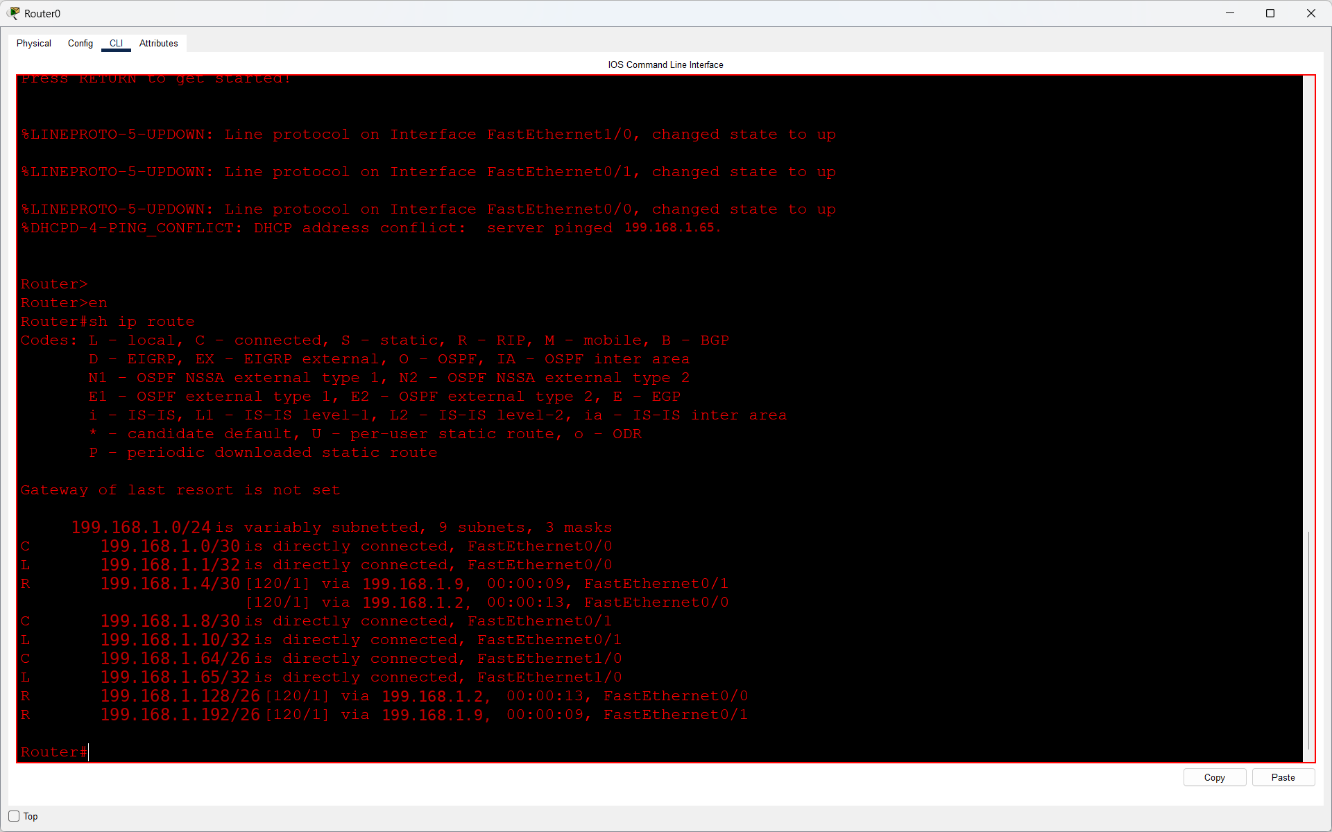
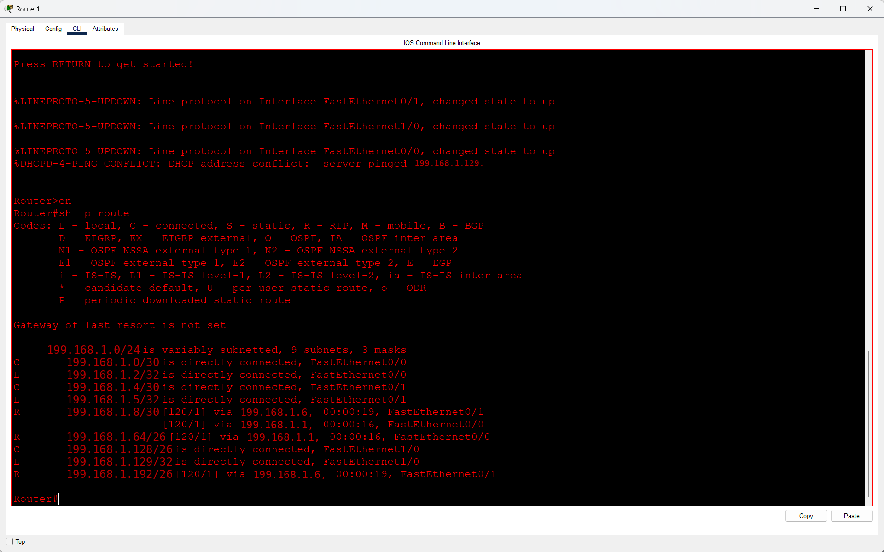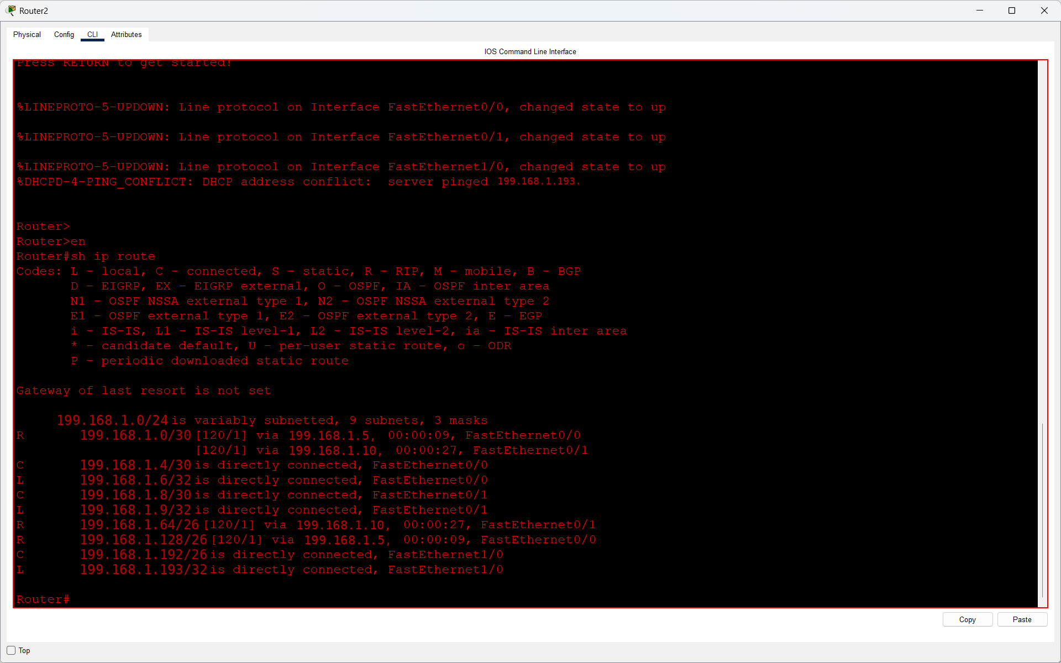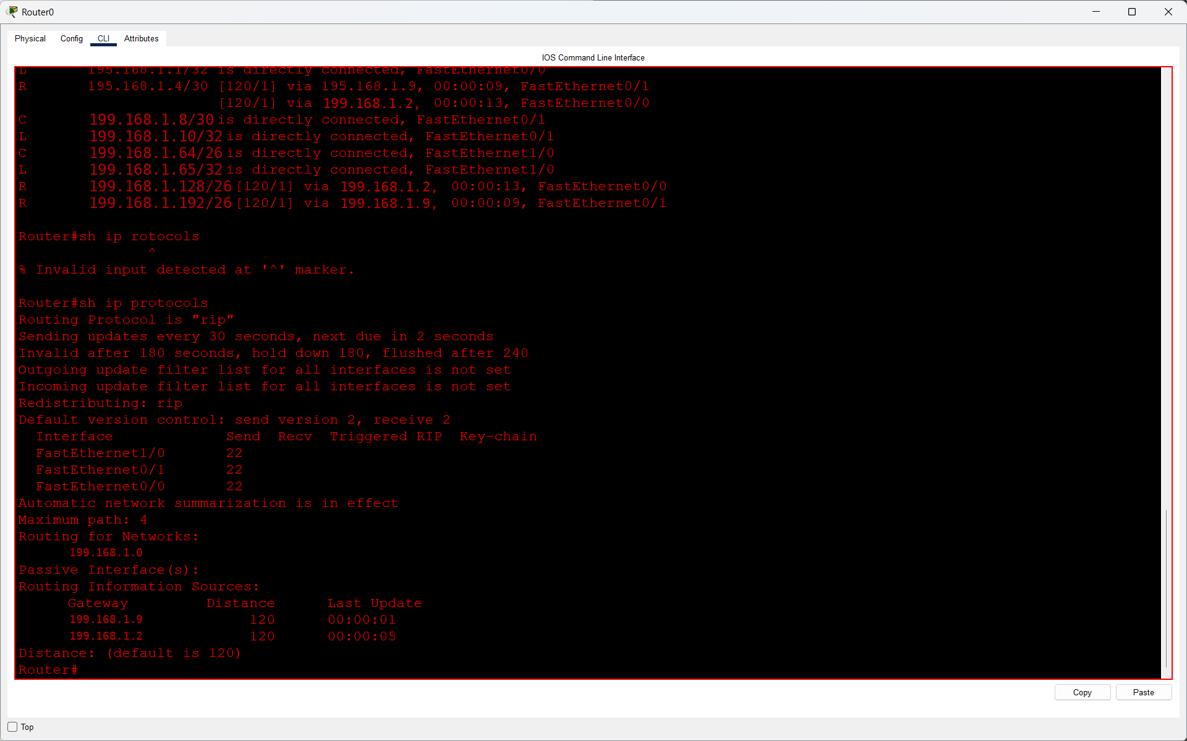

Q3. Change the hop count metric for one of the networks by adding an extra router between two existing routers, then observe and record how the hop count value changes in the routing tables?

Answer
- I added one extra router (Router3) between Router0 and Router1 in my existing RIPv2 topology.
- I connected Router3 using Ethernet cables, assigned IP addresses and configured RIP Version 2.
- After configuration, I used the show ip route command on Router0 to check the routing metric.
- Observation:
Before Adding Router3 | After Adding Router3
- Hop Count = 1 | Hop Count = 2
- [120/1] | [120/2]

The destination network was 199.168.1.128/26.
- Result: The RIP hop count increased from 1 to 2 after adding Router3 because the destination network required passing through an extra router.
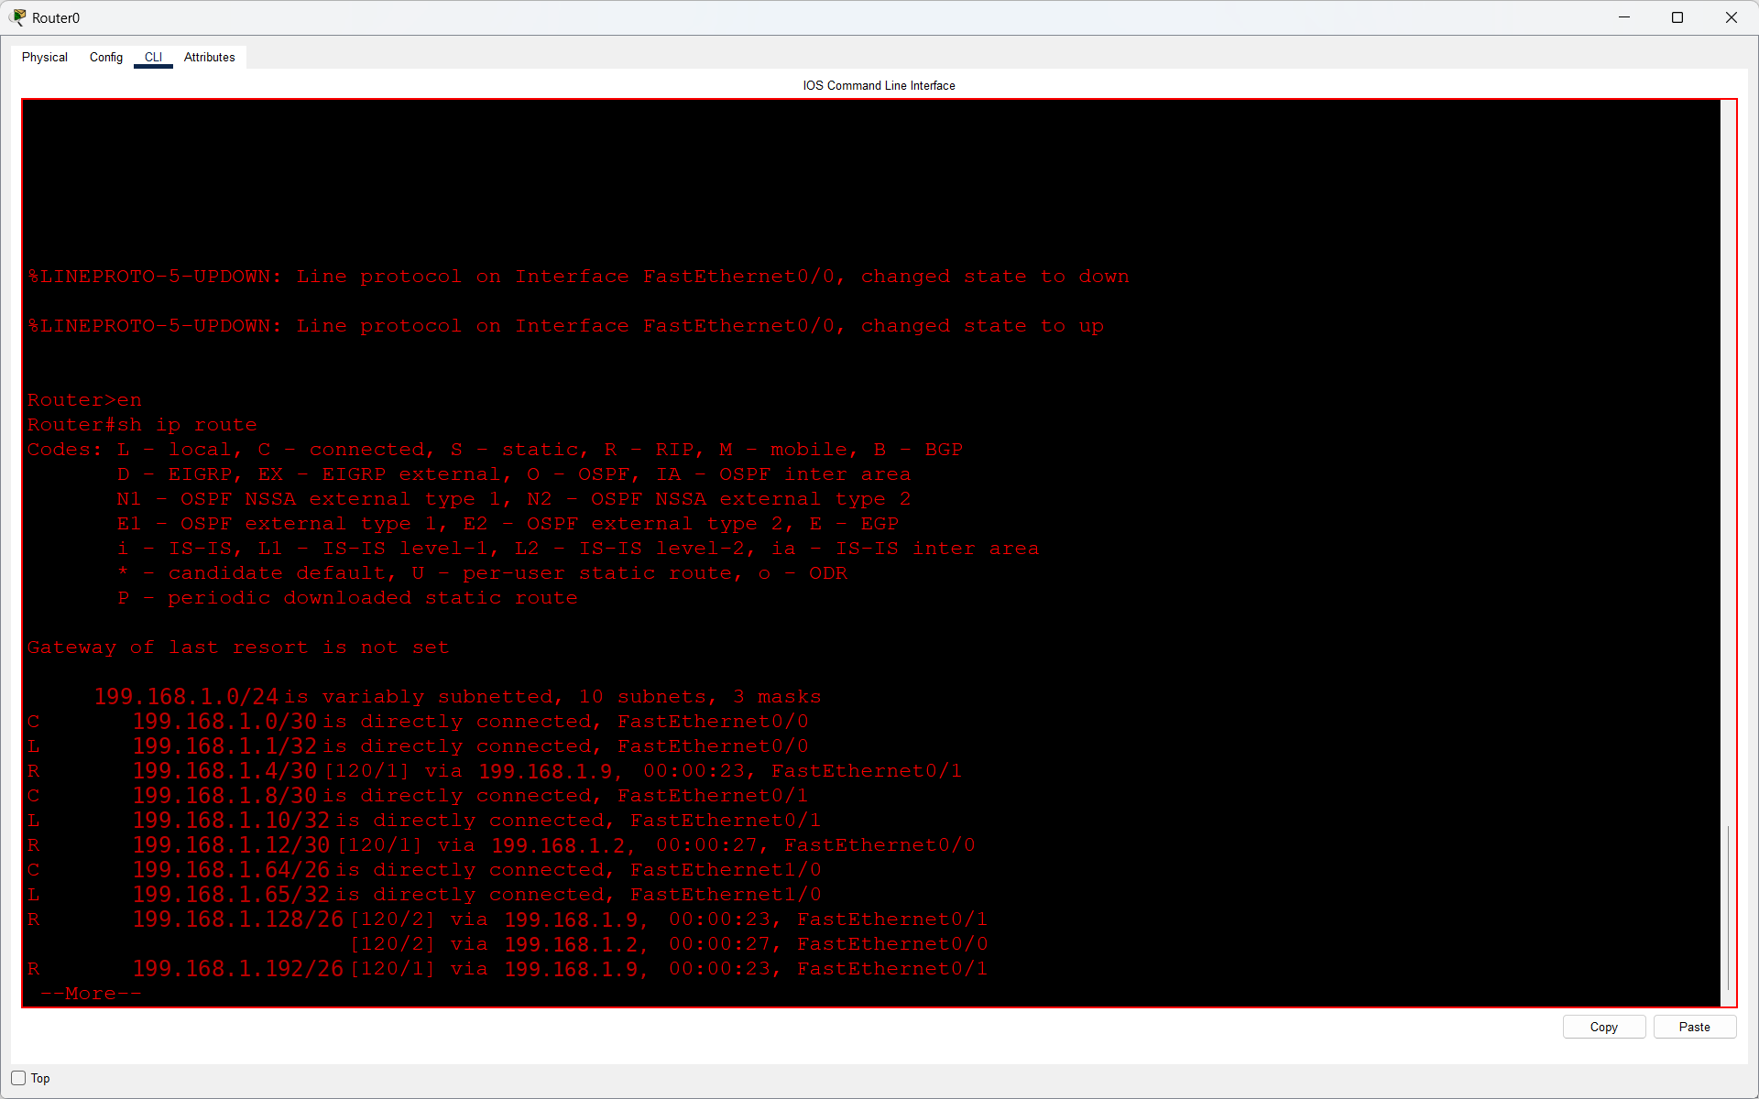
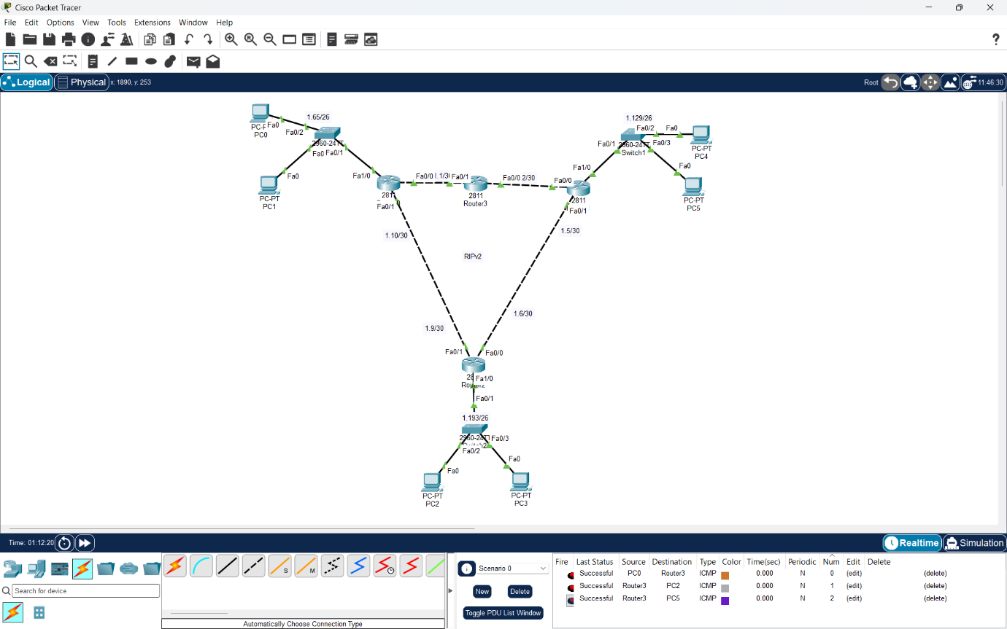

Q4. Use the simulation mode in Cisco Packet Tracer to capture and analyze RIP update packets as they are exchanged between routers.<br><br><em><strong>Hint:</strong> Filter for RIP packets in the simulation panel and note the source, destination, and advertised routes in each update.</em>?

Answer
- I opened my RIPv2 topology in Cisco Packet Tracer and selected Simulation Mode. I applied the RIP filter and captured the routing update packets exchanged between routers.
- I opened the PDU Details window to check the source IP, destination IP, advertised network and hop count metric.

- Observation:
Parameter | Value
- Protocol | RIP Version 2
- Source Router | Router3
- Destination Router | Router0
- Source IP | 199.168.1.2
- Destination IP | 224.0.0.9
- Advertised Network | 199.168.1.4/30
- Next Hop | 199.168.1.2
- Metric | 2
- Update Interval | 30 seconds

Result: I successfully captured and analyzed a RIPv2 routing update packet. The packet contained network information and a hop count metric used by routers to update their routing tables automatically.
